**Group Project Team Roles**

This document is to serve as a template or suggestion for the team project roles and responsibilities. Your team is not required to use this as a project guide, though it may assist you in building a successful team project.

Team projects are challenging. Team member personalities and experiences help determine the goals, function, and success of the project. Once you throw in the project requirements, the plan can get complicated and confusing. While many professional teams rely on methodologies like Scrum, Lean, and Waterfall to build software, the right process will vary from group to group. Success is tied to team work, so it is imperative that your roles are defined and observed throughout the project regardless of the method your team uses.

At the end of the day, it is important to remember that you all have a shared goal-building a quality product that offers a high level of value for your personal development. The goal of this document is to make sure all the key roles and responsibilities are understood and covered. The result is a team built on mutual contribution, respect, and project success.

**Step 1: Inventory the Team Skills**

* Does anyone have a role preference or aversion?
* Does anyone have graphic design skill or specialty program knowledge that can be utilized?
* Do any of the group members have great leadership, time management, or organization skills?
* How do the team skills support one another?
* What will be the strongest and weakest technical aspects of the team?

The core skill sets needed in a web site development team are:

* Strategy and planning
* Information architecture
* Graphic and user-interface design
* Web technology
* Site production

**Step 2: Define Roles & Responsibilities**

The following is a brief overview of responsibilities to consider for the group project.

Each role may correspond to one individual or to a group, or one individual may perform multiple roles, but regardless of how the roles get assigned to individuals, they represent common sets of key skill sets and the way that those skills are applied in achieving the goals of the project.

## Project Management & Information Architecture

The project manager coordinates checks-in with team members to tracks schedules and progress against milestones and facilitates communication both between team members. This role is also responsible for the information architecture of the website and serves as the “planner.” This designer will gather information regarding key objectives, functional requirements, and content requirements. Think of this person as the designer who will lead to process of connecting the dots between the rest of the roles. The information architect organizes and categorizes web site structure and content. The information architect is most active early in the design and planning phases of the project, developing content categorization schemes, consistent site terminology, content structure across the site, and site architecture diagrams that explain the overall site planning This person can also serve as a web development support team member.  
**Key deliverables:** Site map, time-line, refine individual work to compile one cohesive project

## Interface/Experience Design

This team member is concerned with the visual presentation of the website, establishing the site typography, visual interface design, color palette standards, page layout details, and the details of how the graphics, photography, illustrations, and other visuals coordinate the website’s appearance with related materials, or if appropriate start from scratch to develop a visual identity, including logos, fonts and color palettes. In addition, this designer will use key functional and content requirements for the site to develop a set of wireframe designs or a flowchart describing how users will interact with the site. Wireframes are “sketches” of page layouts indicating where functional elements and content will be placed on individual site pages that function like a map for the product. The designer then takes design elements and wireframes and develops a set of web page designs with full visual treatments. The UI designer may then turn these designs into web page templates using HTML and CSS.  
**Key deliverables:** Web page designs, web page templates

## Web Content and Technology

The web content specialist is responsible for organizing, preparing and loading website content, typically collaborating closely with the Interface/Experience Designer for a cohesive user experience. This role needs to have a strong familiarity with site content and the overall objectives of the site. The web content specialist should also have strong copywriting and editing skills. Web content specialists may also work with media files such as audio, video or Flash, and may serve as a media specialist as well. As part of the site planning process the technology lead creates the general blueprints for the collection of technologies that will support the chosen web site technology framework to support and collaborate on the user experience and design.  
**Key deliverables:** Prepared web content, loaded into site pages, ongoing site maintenance, content supports graphics

## Web Development and Production

The web developer (programmer) builds the functionality of the website. Early in the design stage the site production lead is responsible for converting initial web site page mockups, designs, and wireframes. This may include client-side scripting like JavaScript, or JavaScript-based tools like jQuery. The web developer will coordinate with the web designer to build page templates and utilize the site map produced by the information architect.  
**Key deliverables:** Web application code

## Quality Assurance and Editing

This design function can be completed by everyone or a become a specialty role. Quality Assurance is responsible for ensuring that the website functions as intended and serves as a support to the web development side of the project. Quality assurance will determine whether the site functions as it should and will ensure a bug free project. When development and content preparation are complete, the developer will coordinate one or more rounds of testing, collecting feedback to deliver to the web developer for troubleshooting. This process will be repeated as necessary until the site is ready for launch.  
**Key deliverables:** Test cases, test process coordination, ensure functionality of the site, back-end support

**Step 3: Determine the Project**

Now that you have surveyed the group for their time, talents, and program knowledge, it is time to turn to the project itself. During this stage of planning you will need to regulate your primary objectives for the site as well as secondary “stretch” goals.

Things to consider:

* Strengths and weaknesses of your team
* Timeline
* Scope of practice
* Rank of site objectives

**Step 4: Build the Timeline**

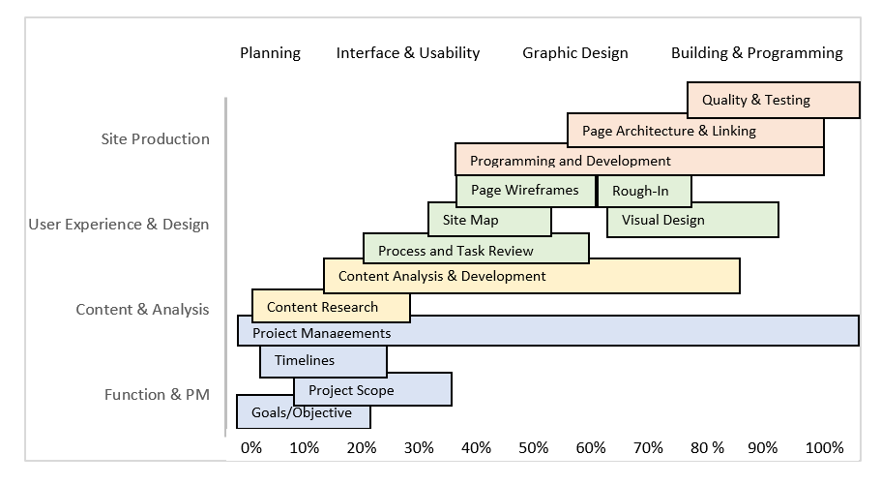

**Step 5: Project Presentation**

Whether the team decided to utilize visual aids beyond the application or not, breaking up the presentation can be done by work role and responsibility, timeline, or the step by step process used to accomplish your project. Please make sure that each group member contributes to the project presentation. It will be important to do a trial run of your presentation so that each group member feels confident with their contribution to the presentation.